VIETNAM - KOREA UNIVERSITY OF INFORMATION AND
COMMUNICATION TECHNOLOGY
DEPARTMENT OF COMPUTER SCIENCE
-----------------------------


GROUP REPORT
ENTREPRENEURSHIP AND INNOVATION
COURSE
PROJECT: GEARPRO BACKPACK

Students | : TRAN THI NGOC ANH – 24IT011  NGUYEN THI THUY HOAN – 24IT074  NGUYEN THI THU THUY – 24IT269  NGUYEN KHANH BUN – 24IT028  PHAM DINH THANG – 24IT244
Class | : KN-ĐMST (01)
Instructor | : ThS. BUI TRAN HUAN

DA NANG, JUNE 2025
VIETNAM - KOREA UNIVERSITY OF INFORMATION AND
COMMUNICATION TECHNOLOGY
DEPARTMENT OF COMPUTER SCIENCE
-----------------------------


GROUP REPORT
ENTREPRENEURSHIP AND INNOVATION
COURSE
PROJECT: GEARPRO BACKPACK

Students | : TRAN THI NGOC ANH – 24IT011  NGUYEN THI THUY HOAN – 24IT074  NGUYEN THI THU THUY – 24IT269  NGUYEN KHANH BUN – 24IT028  PHAM DINH THANG – 24IT244
Class | : KN-ĐMST (01)
Instructor | : ThS. BUI TRAN HUAN

DA NANG, JUNE 2025

INSTRUCTOR'S FEEDBACK
……………………………………………………………………………………
……………………………………………………………………………………
……………………………………………………………………………………
……………………………………………………………………………………
……………………………………………………………………………………
……………………………………………………………………………………
……………………………………………………………………………………
……………………………………………………………………………………
……………………………………………………………………………………
……………………………………………………………………………………
……………………………………………………………………………………
……………………………………………………………………………………
……………………………………………………………………………………
……………………………………………………………………………………
……………………………………………………………………………………

DaNang , day….month….2025
Instructor

ACKNOWLEDGEMENT

Group 9 would like to sincerely thank the lecturers of the University of Information and Communication Technology Vietnam – Korea for providing us with valuable knowledge and lessons during the "Entrepreneurship and Innovation" course.
We especially want to thank Mr. Bui Tan Huan, the lecturer of the "Entrepreneurship and Innovation" course, for his dedicated guidance and support throughout our research. He has given us useful knowledge and helped us better understand our topic. During the project, he spent a lot of time and effort to guide us in completing this work.
This report is the result of our hard work and research during the past semester. Although we have tried our best to improve our knowledge, there may still be mistakes. We would greatly appreciate any feedback from our lecturers and fellow students to help us improve our project.
Thank you very much!
Performed by Students
GROUP 09
Tran Thi Ngoc Anh
Nguyen Thi Thuy Hoan
Nguyen Thi Thu Thuy
Nguyen Khanh Bun
Pham Dinh Thang

TABLE OF CONTENTS
INSTRUCTOR'S FEEDBACK 3
ACKNOWLEDGEMENT 4
TABLE OF CONTENTS 5
INTRODUCTION 8
CHAPTER 1: INDUSTRY OVERVIEW 9
1.1. Market Size and Growth Potential 9
1.2. Key Market Trends 10
1.3. Competitive Landscape 10
1.4. Future Opportunities: 11
CHAPTER 2: INTERVIEWS & SURVEY RESULTS 12
2.1 Demographic Overview of Survey Participants 12
2.2 Identifying Customer Problems 13
2.2.1 Key Questions: 13
2.2.2 Survey Findings: 15
2.3 Understanding Customer Solutions: 17
2.3.1 Key Questions: 17
2.3.2 Survey Findings: 18
CHAPTER 3: CUSTOMER SEGMENTATION 20
3.1 Primary Target Audience 20
3.1.1 Students: Backpacks for School Use 20
3.1.2 Active Individuals: Backpacks for Sports and Gym 21
3.1.3 Versatile Users: Backpacks for Various Daily Purposes 21
3.2 Behavioral and Psychographic Insights 22
CHAPTER 4: PRODUCT DEVELOPMENT & TECHNOLOGY 24
4.1 Product Concept and Features 24
4.1.1 Product Concept: 24
4.1.2 Features: 24
4.2 Technology and Material: 25
4.2.1 Smart Charging System – Stay Powered Anywhere 25
4.2.2 Intelligent GPS Tracking – Security in Every Step 25
4.2.3 Ergonomic Back Massage System – Comfort in Motion 25
4.2.4 Superior Water Resistance – Built for All Weather 25
4.3 Manufacturing Process 26
4.3.1. Customer Needs Research 26
4.3.2. Product Design & Prototyping 26
4.3.3. Material Preparation 26
4.3.4. Assembly Process 26
4.3.5. Quality Control & Testing 26
4.3.6. Finishing & Packaging 27
4.3.7. Distribution & Customer Feedback 27
4.4 Competitive Advantages: 27
4.4.1 All-in-One Functionality 27
4.4.2. Enhanced Comfort with Built-in Massage 28
4.4.3. Smart Safety & Anti-theft 28
4.4.4 Superior Material & Waterproof Design 28
4.4.5. Power On-the-Go 28
4.4.6. Modular & Upgradeable Design 28
4.4.7. Customizable App Integration 28
4.4.8. Targeted for Modern Lifestyles 29
4.5. Swot of backpacks 29
4.5.1. Strengths 29
4.5.2. Weaknesses 30
4.5.3. Opportunities 30
4.5.4.Threats 31
CHAPTER 5: BUSINESS IDEA EVALUATION 32
5.1 Porter’s Five Forces Analysis 32
5.1.1.Threat of New Entrants – Moderate to High 32
5.1.2.Bargaining Power of Suppliers – Moderate 32
5.1.3.Bargaining Power of Buyers – High 32
5.1.4.Threat of Substitutes – Moderate 32
5.1.5.Industry Rivalry – High 32
5.2.Competitor Analysis 32
5.3. Business Viability Assessment 33
5.4. Potential Challenges and Risk Mitigation 33
CHAPTER 6: LEAN STARTUP STRATEGY 35
6.1 Business Model Canvas (BMC) 35
6.1.1 Customer Segments 35
6.1.2 Value Propositions 35
6.1.3 Channels 36
6.1.4 Customer Relationships 36
6.1.5 Revenue Streams 36
6.1.6 Key Resources 37
6.1.7 Key Activities 37
6.1.8 Key Partnerships 37
6.1.9 Cost Structure 37
6.2 Minimum Viable Product (MVP) 38
6.2.1 Objectives of the MVP 38
6.2.2 Features and Functionalities of the MVP 39
6.2.3 MVP Physical Specifications 39
6.2.4 Use Case Simulation 40
6.2.5 Testing & Feedback Collection Process 41
6.2.6 Lessons Learned 41
6.3. Customer Validation Plan 42
6.3.1 Objectives of Customer Validation 43
6.3.2 Target Customer Profiles for Validation 43
6.3.3 Feedback Collection Tools 44
6.3.4 Sample Survey Questions 45
6.3.5 Evaluation Criteria 45
6.4 Marketing Mix – 4Ps (Customer Acquisition Process) 46
6.4.1 Product 46
6.4.2 Price 46
6.4.3 Place (Distribution Channels) 47
6.4.4 Promotion 47
6.4.5 Summary of Customer Acquisition Strategy 48
CHAPTER 7: FINANCIAL PLAN 49
7.1 Capital Plan 49
7.2 Expected Revenue (First Year) 49
7.3 Estimated Costs 50
7.4 Estimated Profit 52
7.5 Financial Risk Considerations 53
APPENDIX 54
QUESTION SURVEY 54

INTRODUCTION
Nowadays, in modern life, backpacks are not just items for carrying personal belongings but have also become essential tools that meet various human needs. With the development of technology, smart backpacks have emerged to enhance convenience, safety, and comfort for users. Additionally, they play a significant role in improving posture and reducing musculoskeletal issues.
With the goal of improving the quality and value of traditional backpacks, we conducted a detailed study on customer needs, pain points, and requirements when using conventional backpacks. At the same time, we analyzed market trends, geographic locations, and customer demographics to propose valuable improvements for this product.
We present our analysis and proposals for transforming traditional backpacks into GearPro Backpack. We will discuss the core benefits of this innovation and evaluate the urgency of developing multi-functional features in the current market.
Our team believes that this report will provide valuable insights and contribute meaningful ideas to the project. We hope that through our focus and dedication, we can better meet customer needs, create a difference, and achieve success in this field.

CHAPTER 1: INDUSTRY OVERVIEW

1.1. Market Size and Growth Potential
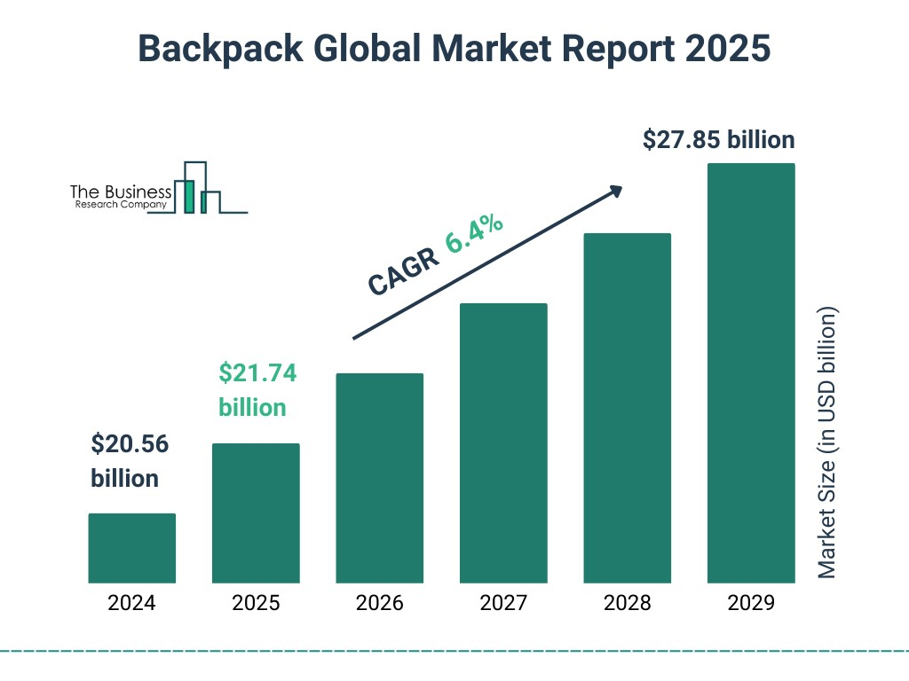
- As of 2025, the global backpack market is estimated to exceed USD 22 billion, showing strong resilience post-pandemic.
- The global backpack market was valued at approximately $21 billion in 2024 and is projected to exceed $30 billion by 2030.
- The increase in tourism and outdoor activities in the United States is promoting backpack sales.
- The global backpack market is valued at billions of dollars and is expected to continue to grow stably in the coming years.
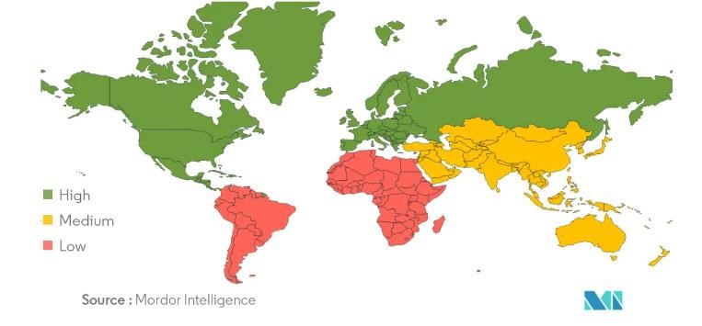
- The Asia-Pacific region holds the largest market share due to rising student populations and increased travel activity.
- North America and Europe are experiencing higher demand for smart and ecofriendly backpacks as sustainability trends grow stronger.
- Emerging markets in Latin America and Africa present new growth opportunities due to increasing urbanization and lifestyle changes.

1.2. Key Market Trends
- Smart Features: Backpacks integrated with charging ports, GPS trackers, and anti-theft systems are gaining popularity.
- Sustainability: Eco-friendly materials and production methods are becoming a major selling point.
- Customization: Modular backpacks with interchangeable compartments cater to different user needs.
- Ergonomic Design: Consumers prioritize comfort and back support to reduce strain during long-term usage.
- Hybrid Usage: People want backpacks that can seamlessly transition between work, travel, and casual use.

1.3. Competitive Landscape
The multi-functional backpack market is highly competitive, featuring:
- Major brands (e.g., Samsonite, The North Face, Herschel, Tumi) constantly innovating to maintain market position.

- Tech startups offering smart backpacks with competitive pricing and unique features.
- DTC (Direct-to-Consumer) strategies are helping brands connect directly with customers.
- Consumer trends are shifting toward minimalist, functional designs, influencing product development.

1.4. Future Opportunities:
- Development of Smart Backpacks: Huge potential for backpacks with advanced technology, targeting young consumers and professionals.
- Expansion into Emerging Markets: Strong growth expected in Asia, Africa, and Latin America.
- Collaboration with Designers and Fashion Brands: Special collections to attract fashion-conscious customers.
- Investment in Sustainability: Opportunities for brands focusing on eco-friendly production, reducing carbon emissions, and using recycled materials.

CHAPTER 2: INTERVIEWS & SURVEY RESULTS
To understand market needs, we conducted two rounds of customer interviews and surveys. The goal was to identify pain points, analyze preferences, and develop a solution that aligns with customer demands.
We surveyed 150 respondents from diverse demographics, including students, business professionals, and frequent travelers.

2.1 Demographic Overview of Survey Participants
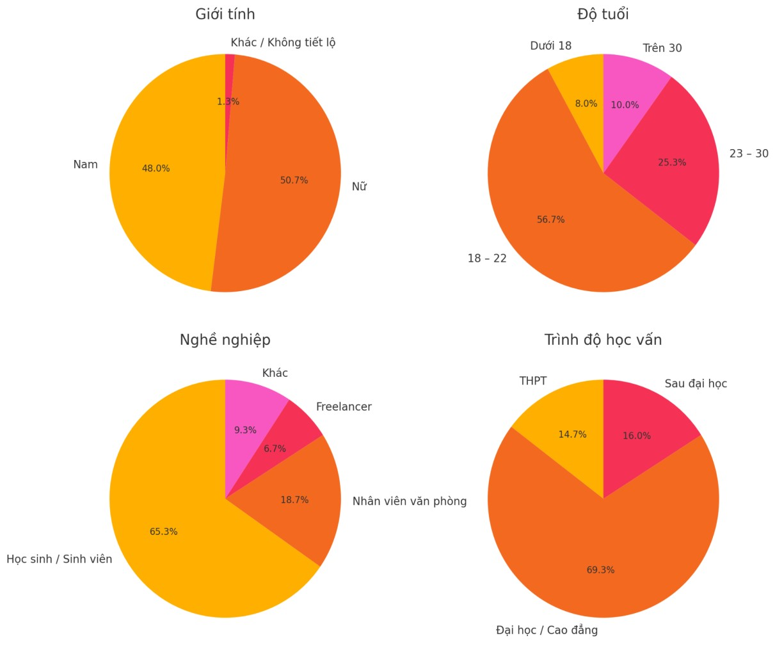
Demographic Overview of Survey Participants

The survey reveals a diverse participant profile:
- Gender: Female respondents slightly outnumber males (50.7% vs. 48.0%), with
1.3% choosing not to disclose or identify as other.
- Age: The majority are aged 18–22 (56.7%), followed by 23–30 (25.3%), indicating a young and likely student-oriented demographic.
- Occupation: Students make up the largest group (65.3%), with office workers (18.7%) and freelancers (6.7%) following.
- Education: Most participants have a college/university background (69.3%), while 16.0% hold postgraduate degrees.
- Conclusion:
The survey predominantly reflects a young, educated population, primarily consisting of students or recent graduates.

2.2 Identifying Customer Problems

2.2.1 Key Questions:
Question 1: What kind of backpack or bag have you been using lately?

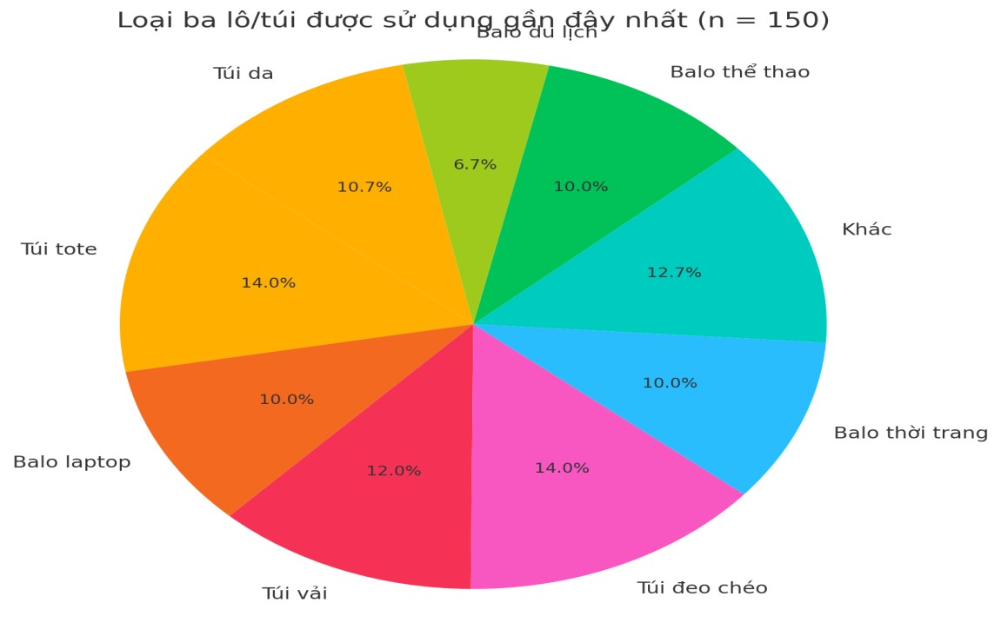

Question 2: What occasions do you usually use a backpack for?
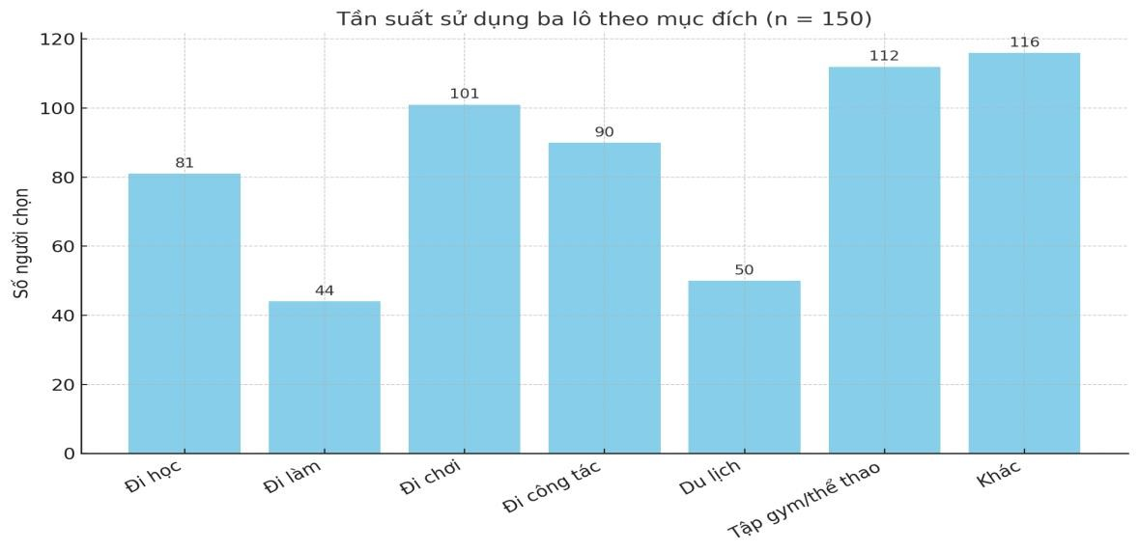
Question 3: Have you ever had any problems when using your backpack?
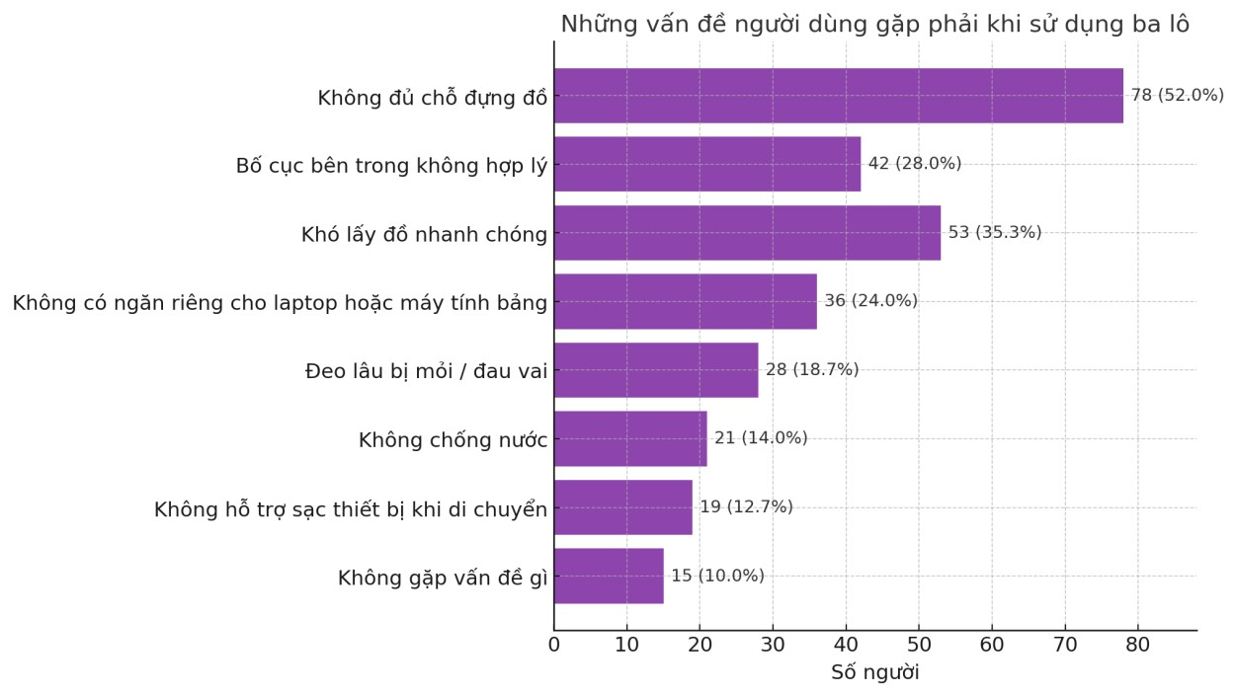
Question 4: How do you solve these problems?
Most response:
- Bought a new backpack with better compartments
- Used additional pouches or organizers
- Carry fewer items to reduce weight
- Use a laptop sleeve or insert a divider
- Use a rain cover or waterproof bag
- Carry a power bank separately
- Customized or modified the backpack
- I haven’t found a good solution yet
Question 5: What problems do you have with the storage space of your current backpack?
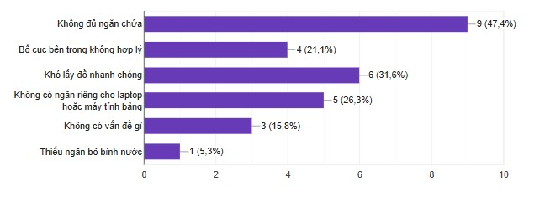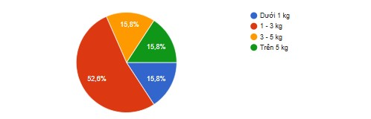

Question

6
:

How much weight do you usually carry in your backpack?

Question 7: Do you feel that your current backpack lacks the necessary features?
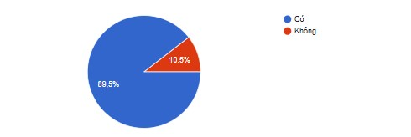

2.2.2 Survey Findings:
Types of backpacks/bags used by customers:
- The most popular choice is fashion backpacks (18%).
- Followed by tote bags (14%) and crossbody bags (14%).
- Laptop backpacks (12%) and leather bags (10.7%) are also notable.
- Customers care about both style and functionality.
Usage occasions for backpacks:
- Most people use backpacks for studying (116 responses).
- Other purposes (112 responses) such as casual outings or travel are also common.
- For work (101 responses) and for outdoor activities (105 responses) are significant.
→ Customers use backpacks in various scenarios, not just for school but also for leisure and daily commuting.
Problems customers face with their backpacks:
- The biggest issue: Not enough storage space (52%).
- Other concerns:
- Poor internal layout (28%).
- Difficult to access items quickly (35%).
- No dedicated laptop or tablet compartment (24%).
→ Customers value convenience and organized compartments in their backpacks.
How customers solve these problems:
- Most common solution: Buy a new backpack with better compartments.
- Other strategies include:
- Using additional pouches or organizers.
- Carrying fewer items to reduce weight.
- Using rain covers or waterproof bags.
→ There is a clear demand for well-designed, smart backpacks or accessories that improve organization.
Storage space issues with current backpacks:
- Main issue: Not enough compartments (47.4%).
- Followed by: Difficult to access items quickly (31.6%).
→ Improved layout and smart storage solutions are key improvements customers look for.
Typical weight customers carry:
- Most people carry under 1 kg (52.6%).
- Next common is 1–3 kg (31.6%).
→ Backpacks should be lightweight and designed for daily use.

2.3 Understanding Customer Solutions:

2.3.1 Key Questions:
Question 8: What additional features would you like to have if you want to buy a new backpack?
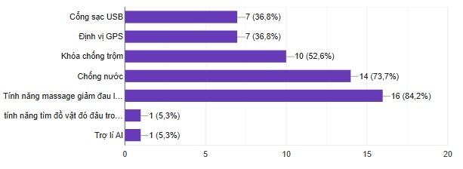
Question 9: Of the above features, how important do you rate each feature? (Use a scale of 1–5)
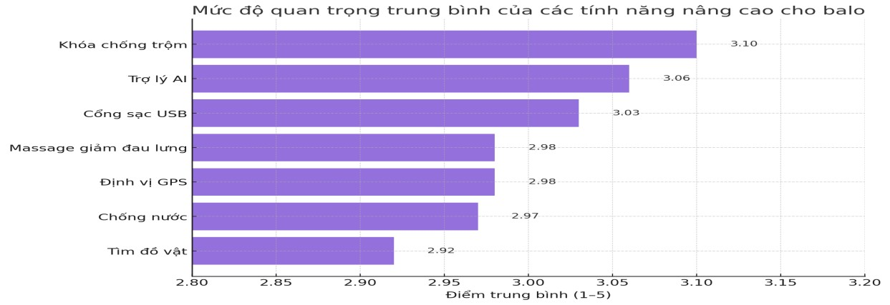
Question 10: What factors influence your decision to buy a new backpack?
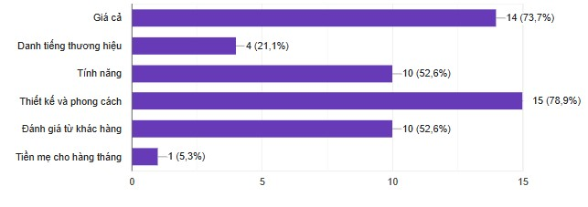
Question 11: How much are you willing to spend on a backpack that suits your needs?

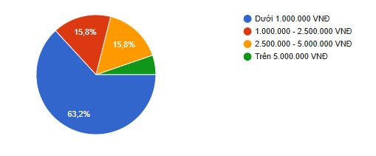
Question 12: Where do you usually look for information about new backpacks?
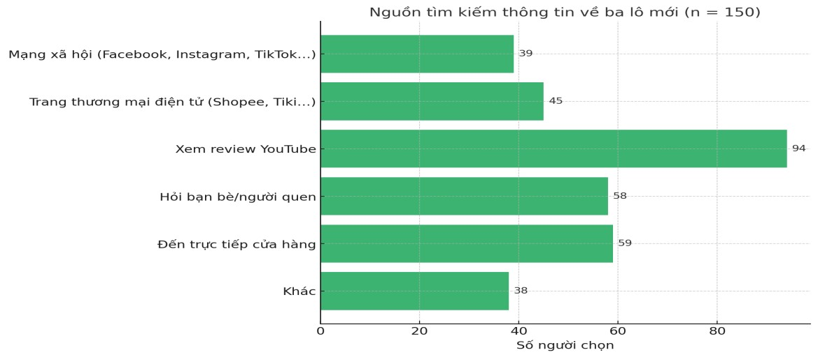

2.3.2 Survey Findings:
Preferred Features: The most desired backpack features include USB charging (36.8%), GPS (52.6%), anti-theft locks, and water resistance. Pain-relief massage features received lower interest (73.7% and 84.2% negative ratings).
Feature Importance: Anti-theft locks (3.10/5) and AI assistants (3.08/5) are rated as the most important features, followed by USB charging (3.03/5), while GPS (2.96/5) and waterproofing (2.97/5) ranked lower.
Purchase Influencers: Price is the dominant factor (73.7%), followed by brand reputation, design/style, customer reviews, and monthly budget. Social influence (e.g., friends) also plays a role (78.9%).
Price Range: 63.2% of respondents are willing to spend between 1,000,000 - 2,500,000 VND, while 15.6% each opt for under 1,000,000 VND or 2,500,000 - 5,000,000 VND.
Information Sources: Social media (e.g., Facebook, Instagram) and ecommerce platforms (Shopee, TikTok) are primary sources. YouTube reviews (45%) and in-store visits (20%) are also significant, with 150 respondents surveyed.

CHAPTER 3: CUSTOMER SEGMENTATION

3.1 Primary Target Audience

Based on the frequency of backpack usage and our research findings, we have identified three primary target audiences, each with distinct needs and preferences. By understanding these segments, we can better tailor our multi-functional backpack to meet their expectations.

3.1.1 Students: Backpacks for School Use
Age Range: Primarily 15–24 years old
Usage Frequency: Daily (school days, extracurricular activities) Primary Needs:
- Large capacity for books, notebooks, and stationery
- Safe and secure laptop compartment
- Lightweight and ergonomic to ease heavy loads
- Affordable price suitable for student budgets Pain Points:
- Overloaded bags causing discomfort
- Lack of organization leading to clutter
- Designs that are either too plain or not trendy Preferences:
- Stylish designs that reflect personality
- Tech integrations like USB charging ports - Weather-resistant material for rainy days.
Insight: Students value both functionality and style. Their backpacks must support academic demands while being comfortable for daily use.

3.1.2 Active Individuals: Backpacks for Sports and Gym
Age Range: 18–35 years old
Usage Frequency: Several times a week (workouts, outdoor activities) Primary Needs:
- Spacious compartments for gym clothes, shoes, water bottles, and towels
- Durable, water-resistant material
- Ventilated sections to separate sweaty gear from personal items Pain Points:
- Inadequate compartments leading to messy storage
- Lack of odor control features
- Difficulty in cleaning the backpack Preferences:
- Lightweight and easy-to-carry design
- Quick-access pockets for essentials (phone, keys)
- Minimalist yet sporty appearance
Insight: Active users prioritize durability, hygiene, and easy organization to match their dynamic lifestyle.

3.1.3 Versatile Users: Backpacks for Various Daily Purposes
Age Range: 25–45 years old
Usage Frequency: Daily or several times a week (commuting, travel, casual outings)
Primary Needs:
- Multi-purpose compartments for work essentials, personal items, and occasional travel needs
- Sleek, professional design suitable for different environments
- Security features like anti-theft zippers and hidden pockets Pain Points:
- Inconvenience of switching bags for different occasions
- Insufficient space for tech gadgets and accessories
- Lack of ergonomic design causing discomfort during long commutes Preferences:
- Smart features such as integrated charging ports
- Weather resistance for all-season use
- Comfortable straps and back support
Insight: Versatile users seek an all-in-one solution that adapts seamlessly to work, leisure, and travel scenarios without compromising style or function.

3.2 Behavioral and Psychographic Insights
criteria for choosing a backpack

- Design & Style are top priorities (78.9%), showing users care about selfexpression and aesthetics.
- Brand reputation is less important (21.1%), indicating openness to newer brands if quality is good.
The average importance of backpack features
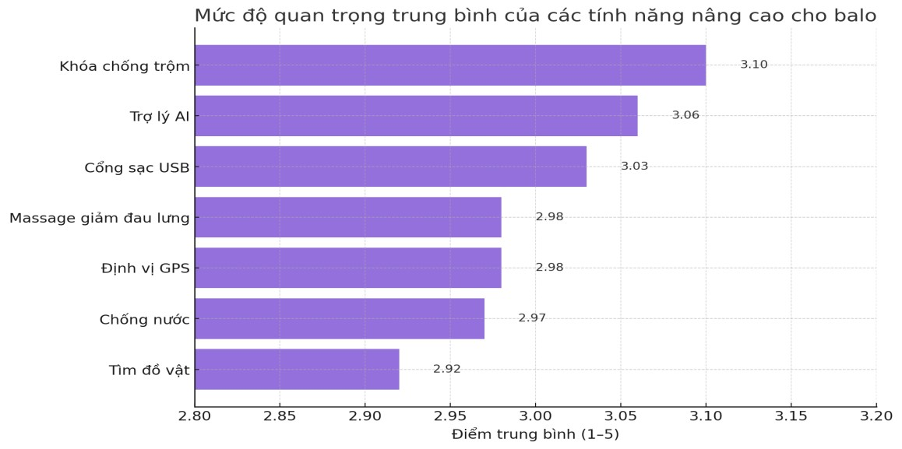
- Desired features include anti-theft locks, AI assistants, and USB ports, showing interest in smart, convenient tech integration.
- Meanwhile, lower interest in GPS or object-finding features suggests users prioritize daily-use practicality over niche or advanced tracking functions.
The weight usually carried

- Users mostly carry 1–3 kg (52.6%), pointing to needs for lightweight, versatile backpacks.
The average desired price

-

Most

users

(63.2%)

prefer

backpacks under 1,000,000 VND, highlighting a

strong demand for affordable options.
- The market leans price-sensitive, with only a small portion (15.8%) willing to pay over 2,500,000 VND, suggesting premium models should offer clear added value.
average importance of backpack features

- Most users research via YouTube reviews (94 votes), followed by friends and in-store visits, showing trust in visual and personal sources.

CHAPTER 4: PRODUCT DEVELOPMENT & TECHNOLOGY

4.1 Product Concept and Features

4.1.1 Product Concept:
A multi-functional backpack is a modern backpack designed with advanced features to meet the diverse needs of users, especially students, office workers, and frequent travelers. It has different functions than a normal backpack: positioning, charging, back massage and waterproofing.

4.1.2 Features:
Charging Capability: The backpack is equipped with a USB port or builtin power bank, allowing users to charge their phones or other electronic devices on the go without opening the backpack. Some versions have internal wiring for safer and more convenient charging.
GPS Tracking: The backpack includes a GPS chip or Bluetooth tracker, enabling users to monitor its location through a mobile app. This is especially useful in case of loss or theft.
Back Massage Function: The backpack features a built-in massage system with vibrating pads or ergonomic cushions. This helps relieve back and shoulder fatigue during long periods of use, particularly when carrying heavy loads.
Water Resistance: Made from water-resistant materials (like Oxford fabric, coated Polyester, or PU), the backpack protects items inside from rain and moisture, keeping electronics and documents safe.

4.2 Technology and Material:

4.2.1 Smart Charging System – Stay Powered Anywhere
The backpack features a built-in USB charging port conveniently located on the side, allowing users to charge smartphones, tablets, or Bluetooth devices without opening the bag.
Inside, a carefully designed cable system connects to your power bank, ensuring safety and neatness during use.
Some premium models even support wireless charging, offering an even more modern and seamless experience.

4.2.2 Intelligent GPS Tracking – Security in Every Step
Equipped with an integrated GPS chip or Bluetooth tracker, the backpack allows real-time location tracking via a smartphone app.
This is especially useful for anti-theft protection, recovering lost items, or keeping track of children or students.
Some models support geofencing, alerting you when the backpack moves beyond a defined safe zone.

4.2.3 Ergonomic Back Massage System – Comfort in Motion
Designed for long hours of wear, the backpack includes vibrating massage modules embedded in the back panel—strategically placed along the shoulders, spine, and lower back.
When activated, the massage helps to relieve pressure, reduce fatigue, and improve blood circulation, especially for those who carry heavy loads or commute frequently.
This feature operates via a rechargeable battery unit, easily charged through a standard USB cable.

4.2.4 Superior Water Resistance – Built for All Weather
Crafted from high-quality waterproof materials such as Oxford fabric,PUcoated or TPU-treated polyester, the backpack provides excellent protection against rain and moisture.
It also includes waterproof zippers and heat-sealed or bonded seams, ensuring that even your most sensitive electronics and documents remain safe in harsh weather.
Ideal for travelers, commuters, students, or professionals who carry laptops, tablets, or important gear daily.

4.3 Manufacturing Process

4.3.1. Customer Needs Research
- Methods: Online surveys, interviews, focus groups, competitor analysis.
Goals:
- Identify desired features: charging, massage, waterproof, GPS, etc.
- Understand use cases: commuting, travel, students, professionals.
- Define price expectations and preferred design styles.

4.3.2. Product Design & Prototyping
- Use research insights to create 2D sketches and 3D CAD designs.
- Plan internal layout for battery pack, USB port, massage module, GPS.
- Develop the first working prototype for internal testing and user feedback.

4.3.3. Material Preparation
Fabric: Water-resistant materials (e.g., PU-coated Oxford, polyester).
Components:
- USB charging module + battery.
- Vibration motor for massage.
- GPS/Bluetooth module.
Wiring, switches, protective foam, waterproof zippers.
Cut fabric using CNC or laser machines based on design templates.

4.3.4. Assembly Process
Sewing: Assemble backpack structure, padding, compartments.
Electronics Integration:
- Install USB charging system connected to a secure power bank.
- Embed vibration motors in the back panel with a control switch.
- Secure GPS tracker in a protected, hidden pocket.
durability
Route wiring safely inside fabric layers, ensuring insulation and

4.3.5. Quality Control & Testing
Functionality Tests:
- Charging port performance with multiple devices.
- Massage strength and heat safety.
- Real-time GPS tracking and mobile connectivity.
Physical Tests:
- Waterproof testing (spray or submersion).
- Strap strength, zipper endurance, load testing.
Electrical Safety: Short-circuit protection, heat resistance.

4.3.6. Finishing & Packaging
- Add branding, instruction manual, warranty card.
- Pack in eco-friendly box with protective padding.
- QR code linking to app (for GPS/massage control or registration).

4.3.7. Distribution & Customer Feedback
Distribute via retail, online stores, or direct shipping.
Collect user feedback after purchase:
- Satisfaction with features, usability, comfort.
- Bug reports or improvement suggestions.
Use feedback to iterate future versions (e.g., V2, V3).
PROCESS FLOW SUMMARY:
Customer Research ➝ Product Design ➝ Material Preparation ➝
Assembly ➝ Testing ➝ Packaging ➝ Distribution ➝ Feedback ➝ Improvement

4.4 Competitive Advantages:

4.4.1 All-in-One Functionality
- Combines charging, massage, waterproofing, and GPS tracking in one compact product.
- Eliminates the need for carrying multiple accessories (power bank, trackers, massage devices...).
=> Most competing products offer only 1–2 smart features; ours integrates 4+ seamlessly.

4.4.2. Enhanced Comfort with Built-in Massage
- First-of-its-kind ergonomic massage system embedded into the back panel.
- Ideal for commuters, travelers, and students suffering from back fatigue.
=> Transforms the backpack from just a carrying tool into a personal wellness device.

4.4.3. Smart Safety & Anti-theft
- GPS tracking helps locate lost or stolen bags.
- Option for geofencing alerts and remote lock via app (upgrade-ready).
=> Adds peace of mind in urban and travel environments.

4.4.4 Superior Material & Waterproof Design
- Uses premium water-resistant fabrics, sealed zippers, and inner linings.
- Protects both electronics and valuables in all weather conditions.
=> Standout durability compared to regular tech or travel backpacks.

4.4.5. Power On-the-Go
- Integrated USB port connects directly to a secured power bank compartment.
- Supports fast charging protocols (e.g., QC, PD) in premium models.
=> Ensures your devices stay powered all day—anywhere, anytime.

4.4.6. Modular & Upgradeable Design
- Each smart module (charging, massage, GPS) is designed to be repaired or upgraded independently.
- Encourages long-term use and sustainability.
=> Reduces e-waste and lowers total ownership cost.

4.4.7. Customizable App Integration
- Mobile app allows users to:
- Monitor GPS position.
- Adjust massage settings.
- Receive battery or movement alerts.
=> Tech-savvy experience tailored to user preferences.

4.4.8. Targeted for Modern Lifestyles
- Designed with urban users, students, professionals, and digital nomads in mind.
- Blends smart tech with modern aesthetics—stylish and functional.
=> Perfectly positioned for growing smart-wearable and EDC (everyday carry) markets.
=> Summary of Key Differentiators:
Feature | Regular backpack | Other smart bags | Our product
USB charging | ❌ | ✅ | ✅
Massage System | ❌ | ❌ | ✅
GPS tracking | ❌ | ⚠️ | ✅
Waterproof protection | ⚠️ | ⚠️ | ✅
Mobile app integration | ❌ | ⚠️ | ✅
Custom design options | ⚠️ | ⚠️ | ✅

4.5. Swot of backpacks
A comprehensive SWOT analysis helps identify the internal strengths and weaknesses, as well as the external opportunities and threats that may affect the GearPro Backpack’s performance in the market. This analysis allows the team to develop informed strategies that leverage advantages, address limitations, and prepare for competitive and environmental challenges.

4.5.1. Strengths
One of the key strengths of the GearPro Backpack lies in its integration of advanced technology into a product that is already essential to everyday life. Unlike traditional backpacks, GearPro offers smart features such as an external USB charging port, Bluetooth-enabled GPS tracking, and an ergonomic back massage system. These functionalities enhance not only convenience but also comfort, making the backpack particularly appealing to students, digital nomads, commuters, and professionals who are constantly on the move.
In addition to its smart capabilities, the backpack’s water-resistant material provides added protection for valuable items such as laptops and electronics, especially during unpredictable weather conditions. The overall design emphasizes modern aesthetics and functional innovation, which resonates strongly with tech-savvy, urban consumers who are looking for more than just a basic bag. This unique combination of utility, style, and smart integration sets GearPro apart from many traditional and even tech-adjacent competitors in the market.

4.5.2. Weaknesses
Despite its innovative edge, the GearPro Backpack also has a few notable weaknesses that could affect user adoption, particularly in more price-sensitive segments. Firstly, the inclusion of smart features and electronic components naturally leads to a higher retail price compared to standard backpacks. This may discourage budget-conscious customers, especially students with limited income
Additionally, the inclusion of devices such as GPS chips and massage modules increases the overall weight of the backpack, potentially affecting comfort for long periods of wear, especially when the bag is fully loaded. Another concern is the product’s dependence on battery power — users must regularly charge the internal power bank or GPS chip for the features to remain functional. Without proper battery management, the smart functions become ineffective, which could result in user dissatisfaction.
Lastly, due to the complexity of the internal electronic system, concerns about long-term durability may arise. Any malfunction in the smart components could require specialized repair or replacement, which may not be as accessible or affordable for all users. These technical dependencies could also make the product feel intimidating or unnecessary to consumers who prefer simple, low-maintenance accessories.

4.5.3. Opportunities
The GearPro Backpack is well-positioned to capitalize on several favorable market trends. Globally, there is a growing interest in smart lifestyle products as consumers increasingly prioritize efficiency, mobility, and technology in their daily routines. The rising popularity of wearable tech and smart accessories suggests a receptive audience for products like GearPro, especially among younger demographics, urban professionals, and frequent travelers.
Additionally, the backpack’s emphasis on ergonomic design and posture health aligns with contemporary health and wellness movements. More people are becoming aware of the impact of heavy bags on spinal health, especially those who carry laptops and other devices daily. GearPro’s comfort-focused features, including back padding and future massage integration, address this growing concern.
The product also presents strong potential as a premium corporate gift. Businesses seeking innovative, tech-forward presents for staff, partners, or VIP clients may find GearPro to be a valuable offering. Furthermore, the brand has international appeal, with the possibility to scale into global e-commerce platforms or expand to lifestyle stores in major cities. Lastly, future upgrades, modular enhancements, and customization options (e.g., color, branding, added features) offer long-term value and continued user engagement, opening doors for repeat customers and brand loyalty.

4.5.4.Threats
While GearPro benefits from strong positioning, it also faces several external threats that must be carefully managed. The most pressing risk is the rapid evolution of technology — features that are considered innovative today could become standard or obsolete within a few years. Without continuous innovation and updates, the product may struggle to remain competitive.
Moreover, the backpack market is highly saturated, and established brands with greater resources may quickly develop similar products at lower prices or with stronger brand trust. This could make it difficult for a new entrant like GearPro to maintain market share unless it differentiates strongly on quality, service, or unique functionality.
Technical issues such as malfunctioning GPS chips or charging ports could also impact customer trust. In the smart product segment, even minor failures can lead to poor reviews and brand reputation damage. Additionally, certain external factors such as airline regulations on lithium batteries could restrict the backpack’s usage in specific travel scenarios, especially international flights.
Lastly, some consumers may still question the actual necessity of smart features in a backpack. For users who prefer simplicity and functionality over tech integration, GearPro may seem excessive or over-engineered. This highlights the need for effective education and communication to clearly convey the practical benefits of each feature.

CHAPTER 5: BUSINESS IDEA EVALUATION

5.1 Porter’s Five Forces Analysis

5.1.1.Threat of New Entrants – Moderate to High
The backpack industry has a relatively low barrier to entry, especially for startups using e-commerce platforms and drop shipping. However, branding, supply chain management, and product differentiation are key to standing out.

5.1.2.Bargaining Power of Suppliers – Moderate
Depending on the complexity of materials (e.g., waterproof fabric, solar panels, built-in charging systems), reliance on specialized suppliers can increase. However, bulk production can reduce costs over time.

5.1.3.Bargaining Power of Buyers – High
Customers have many options, making quality, price, and unique features crucial. Online reviews and price comparison tools increase buyer power.

5.1.4.Threat of Substitutes – Moderate
Traditional backpacks and single-purpose bags still dominate. However, the shift toward minimalism and multifunctionality offers a competitive edge.

5.1.5.Industry Rivalry – High
The market is saturated with brands like Herschel, Samsonite, and SwissGear. Competing on innovation, branding, and sustainability is essential to stand out.

5.2.Competitor Analysis
Opportunity: There is a gap in the market for a backpack that combines affordability, tech-integration, sustainability, and modern aesthetics.

Brand | Strengths | Weaknesses
Herschel | Stylish design, lifestyle branding | Limited tech features
Samsonite | Strong brand reputation, durability | Less innovative in style and smart features
Nomatic | Highly functional, modular design for travel | Expensive, limited accessibility
Tigernu | Affordable, practical, antitheft features | Weak global brand presence
XD Design | Focus on anti-theft and ecofriendly features | More utility-focused than fashionable

5.3. Business Viability Assessment
Target Audience: Urban professionals, students, tech enthusiasts, digital nomads, travelers.
Unique Selling Points:
- USB charging port or solar power bank compatibility
- Anti-theft zippers and hidden pockets
- Waterproof and eco-friendly materials
- Modular compartments for different uses
- Sleek, professional, and minimalist design Revenue Model:
- Direct-to-consumer sales via e-commerce platforms
- Wholesale partnerships with retailers
- Corporate gifting or branded bulk orders Cost Considerations:
- Initial prototyping and design
- Bulk manufacturing costs
- Branding and marketing efforts
- Shipping, warehousing, and fulfillment
Scalability: High potential to scale through online platforms, international shipping, and product line extensions (e.g., tech organizers, sling bags, travel kits).

5.4. Potential Challenges and Risk Mitigation

Challenge | Risk Mitigation Strategy
Market saturation and competition | Focus on a niche, innovate with smart features and modularity
High customer expectations | Consistent product quality, excellent after-sales service
Supply chain disruption | Multiple suppliers, buffer stock, regional manufacturing partners
High marketing and acquisition costs | Use organic marketing, influencer partnerships, SEO
Copycat products and intellectual theft | File for design patents, trademarks, and strong branding
Negative feedback or poor reviews | Offer warranty, fast customer support, test products thoroughly

CHAPTER 6: LEAN STARTUP STRATEGY

6.1 Business Model Canvas (BMC)
To clarify the core structure of our business model, we have applied the Business Model Canvas (BMC) framework. This model provides a comprehensive overview of how the GearPro Backpack project delivers value, reaches customers, and sustains profitability.

6.1.1 Customer Segments
GearPro targets three distinct customer segments, each with specific needs and behaviors. The primary segment consists of students aged 15–24, who require backpacks for daily academic use, including carrying books, stationery, laptops, and personal gadgets. These users value functionality, comfort, and affordability. The second segment includes young professionals and digital nomads aged 25–35 who frequently move between workspaces, meetings, or travel. They seek stylish, professional-looking backpacks equipped with smart features such as charging ports and GPS for added productivity and security. The third segment consists of active individuals and travelers, including gym-goers and adventure seekers, who need durable, water-resistant backpacks with compartments for sportswear, shoes, and tech accessories. By focusing on these diverse yet overlapping groups, GearPro effectively captures a large share of the smart backpack market with a solution that adapts to work, study, and lifestyle demands.

6.1.2 Value Propositions
The GearPro Backpack delivers exceptional value through an innovative fusion of technology, comfort, and design. Unlike conventional backpacks, GearPro integrates USB charging ports, GPS tracking, ergonomic back massage systems, and waterproof materials, offering a fully functional and future-ready carrying solution. The backpack is also modular, allowing specific components (charging systems, GPS modules, massage units) to be repaired or upgraded independently, promoting long-term usability and sustainability. Its sleek and minimalist design caters to the modern aesthetic preferences of young users, while its functionality aligns with the practical demands of urban living and mobility. GearPro not only solves everyday pain points like disorganization, back strain, and battery anxiety, but also provides peace of mind and a sense of personalized comfort. This combination of smart utility, health-conscious design, and fashion appeal positions GearPro as a game-changing product in the emerging smart-gear market.

6.1.3 Channels
GearPro leverages a digital-first distribution model to reach its tech-savvy target audience. Key online sales channels include popular e-commerce platforms such as Shopee, Lazada, and TikTok Shop, which are highly trafficked by Vietnamese and Southeast Asian consumers. A dedicated GearPro website will be developed to offer direct purchases, customer service, and product customization options. On the promotional side, social media platforms like Facebook, Instagram, and YouTube will play a vital role in creating awareness, engaging customers, and building a community around the product. Content will include influencer unboxings, tutorials, and user testimonials. Additionally, select offline retail partnerships in tech accessory stores or university bookstores will allow for in-person product experiences, particularly for students and office workers who prefer to test before purchase. This hybrid channel strategy ensures both wide reach and accessibility while keeping overhead costs optimized.

6.1.4 Customer Relationships
GearPro aims to build long-lasting and trust-based relationships with its customers. The brand will offer responsive online support, including chatbots and live agents to assist with inquiries, orders, and technical issues. To enhance customer confidence, GearPro will provide comprehensive product tutorials, how-to videos, and clearly outlined warranty policies. Post-purchase engagement will be reinforced through surveys, user feedback programs, and participation in product development cycles (e.g., beta testing new features). The project also plans to build a customer community via social media groups and newsletter campaigns to encourage loyalty and advocacy. Customers will be invited to share their experiences, leave reviews, and earn rewards through referral and loyalty programs. Overall, the strategy focuses on interactive, user-driven relationship management that encourages retention and brand co-creation.

6.1.5 Revenue Streams
GearPro's primary source of revenue will be direct sales to individual customers via its e-commerce channels and official website. Multiple product tiers (standard and premium editions) allow for price segmentation, targeting both budget-conscious students and professionals willing to pay for enhanced features. Secondary revenue streams include B2B sales, such as bulk orders for universities, tech companies, and corporate gifting programs. Customization services (e.g., branded logos or color themes) offer additional income opportunities. In the longer term, GearPro plans to diversify its product line by launching complementary smart gear — such as tech organizers, sling bags, and travel kits — to increase customer lifetime value. Subscription-based app services or premium features (e.g., GPS geofencing alerts, app upgrades) may also contribute to recurring revenue.eloped based on customer willingness to pay, as outlined in Section 2.3.

6.1.6 Key Resources
To implement this business model, GearPro relies on several critical resources. These include a skilled product design and R&D team for innovation and prototyping, along with trusted suppliers of high-quality materials such as waterproof fabric, charging modules, and GPS chips. Access to reliable manufacturing partners (domestic or overseas) is crucial for consistent production. On the digital front, a software development team is needed to create and maintain the mobile app that manages backpack features. Additionally, GearPro will invest in marketing and content creation specialists to manage campaigns, social media, and brand identity. Finally, a robust logistics and fulfillment infrastructure, supported by third-party logistics providers (3PL), is necessary to ensure smooth delivery and returns.

6.1.7 Key Activities
GearPro's key activities span across the entire product and customer journey. These include market research, product design, and prototyping based on user feedback. Once developed, the team oversees component sourcing, manufacturing, and quality control testing to ensure durability and performance. On the commercial side, GearPro must carry out digital marketing campaigns, e-commerce management, and customer service operations. Content creation is another ongoing task, including photography, video production, and influencer collaboration. Maintaining and updating the GearPro mobile app will also be a continuous effort. Additionally, logistics, packaging, and post-sale support complete the loop, ensuring customer satisfaction and opportunities for product iteration.

6.1.8 Key Partnerships
To operate efficiently and scale effectively, GearPro will establish partnerships across its value chain. These include suppliers and manufacturers of electronic components, fabric, and accessories. Collaboration with e-commerce platforms ensures access to built-in traffic, sales tools, and logistics support. Strategic alliances with influencers, YouTubers, and KOLs will help boost product visibility and trust. GearPro may also partner with universities, coworking spaces, and gyms for brand placement or promotions. Finally, technology partners may be required for app development, secure payment integration, and data management.

6.1.9 Cost Structure
The cost structure of GearPro is largely comprised of product development and manufacturing expenses, including material sourcing, prototyping, and assembly. Marketing and promotional spending, such as influencer fees, social ads, and content creation, represent another major category. Operational costs include platform maintenance (website/app), logistics and shipping, customer service infrastructure, and administrative expenses. To maintain a lean model, GearPro will outsource non-core activities like fulfillment and focus on scalable, digital-centric processes. As the company grows, R&D investments will be allocated toward enhancing smart features, sustainability, and personalization.

6.2 Minimum Viable Product (MVP)
The Minimum Viable Product (MVP) for the GearPro Backpack represents the earliest functional version of the product, developed with a lean, focused approach to address the most pressing needs identified through customer surveys and interviews. Rather than waiting to perfect every feature, the MVP allows the team to deliver immediate value, test key assumptions, and iterate quickly based on real-world feedback—minimizing risk while maximizing learning.
Designed with the essential functionalities most demanded by target users, the MVP is a simplified yet effective solution. It offers a clear value proposition: an affordable, tech-friendly, and comfortable backpack that addresses everyday challenges such as device charging, item loss, and exposure to rain. By deploying this MVP, the project team aims to measure user satisfaction, gather detailed insights, and determine the viability of additional smart features (such as massage systems and advanced app integration) in future iterations.

6.2.1 Objectives of the MVP
The MVP for GearPro Backpack is designed to fulfill three primary objectives that align with both our business strategy and customer validation goals.
First, it aims to validate market demand for smart backpack features such as external charging ports, water resistance, and basic tracking systems. Through real usage, we want to determine whether users in our target segments—students, professionals, and active individuals—are genuinely interested in these functionalities and willing to integrate them into their daily routines.
Second, the MVP is intended to evaluate the product's usability, comfort, and practicality in real-life situations. This includes testing how the backpack feels when carried over long durations, how accessible its compartments are, and how effectively the USB and tracking features work during commuting, studying, or exercising.
Third, we aim to collect actionable customer feedback that can be directly applied to improve the final version of the backpack. This includes comments on material quality, design, feature integration, and even pricing expectations. With this feedback, we can confidently plan for the inclusion of more advanced features in future product versions without guessing what users want or need.

6.2.2 Features and Functionalities of the MVP
Through insights gathered from customer interviews and survey responses (Chapter 2 and Chapter 3), we identified the top pain points experienced by users and selected the four most relevant and feasible features to include in our MVP.
The first and most appreciated feature is the USB charging port. The MVP integrates a USB socket on the side of the backpack, which connects internally to a compartment specifically designed for holding a power bank. This allows users to charge smartphones or tablets conveniently without needing to unzip or access the inside of the bag. Importantly, for safety and cost-efficiency, the MVP does not include a built-in battery—users are expected to use their own power banks.
The second feature is basic GPS tracking, implemented through a small Bluetooth chip inserted into a hidden interior pocket of the backpack. This tracker can be linked with common third-party mobile apps like Apple Find My or Tile, enabling users to locate their backpack in case of misplacement or theft. Although this is not a full GPS system, it satisfies the basic need for security in public spaces, especially for students and professionals who work in shared environments.
Thirdly, the MVP is constructed using PU-coated Oxford fabric, which is resistant to light rain and moisture. Combined with protective flaps over the zippers, this design helps to safeguard electronic items such as laptops and tablets inside the backpack. This feature addresses one of the top concerns from surveyed users who highlighted the need for weather protection for their devices.
Finally, the backpack is designed with ergonomic back padding, which includes breathable mesh and contoured support zones. While the actual massage system is not included in this version, the design already anticipates its future integration. Even without the massage function, the current padding provides significant comfort, particularly for those who carry the bag for extended periods.

6.2.3 MVP Physical Specifications
Parameter | Details
Dimensions | 45 cm (height) x 30 cm (width) x 16 cm (depth)
Capacity | Approx. 22–25 liters
Weight | ~900 grams (without power bank)
Material | PU-coated Oxford fabric, nylon lining
Compartments | Main storage, laptop sleeve (15.6”), accessories pocket, power bank slot
Color Options | Black, Navy Blue
Estimated Unit Cost | 550,000 – 700,000

6.2.4 Use Case Simulation
To assess how well the MVP meets real-world needs, we designed three simulated usage scenarios, each based on a core customer segment.
In the Student Use Case, a university student uses the backpack to carry their laptop, charger, books, and personal accessories. During long study sessions on campus, they use the USB charging port to keep their phone powered without looking for outlets. The waterproof fabric keeps their belongings safe when unexpected rain hits while walking between classes.
In the Active Individual Use Case, a fitness enthusiast brings their gym clothes, towel, and water bottle in the backpack. The tracking chip provides peace of mind in public locker rooms or busy spaces. The ergonomic design ensures comfort, especially when walking or biking to the gym.
For the Professional Use Case, a young office worker uses the backpack during their commute. The minimal, sleek design matches a business outfit, and the external USB charging port allows them to work on-the-go. They appreciate the organized layout, which separates work essentials from personal items.
These scenarios show that even in its simplest form, the MVP effectively supports a wide range of lifestyles, professions, and daily activities, thus confirming its relevance.

6.2.5 Testing & Feedback Collection Process
To validate the MVP’s performance, the team organized a 7-day usability trial involving 20 volunteer participants from the main customer segments. This included 10 students, 6 young professionals, and 4 fitness/outdoor users. Each participant received an MVP backpack and used it in their daily routine, from commuting and working to attending class or visiting the gym.
At the end of the trial, participants completed a structured survey and joined a 10-minute interview to share feedback. The results were highly informative. For the USB charging port, users described it as “very convenient” and used it daily, though some suggested a longer internal cable. For the GPS feature, users appreciated the security it provided but found the app pairing slightly confusing. The water resistance was effective against light rain, but several users requested waterproof zippers for added protection. The ergonomic padding received positive reviews for its comfort, and many expressed excitement about trying a future version with an integrated massage system.
Preliminary Feedback Summary:
Feature | Positive Feedback | Suggested Improvements
USB Charging Port | “Very convenient, used daily.” | “Cable could be slightly longer.”
GPS Tracking | “Helpful peace of mind.” | “App pairing was a bit confusing.”
Water Resistance | “Handled light rain well.” | “Would like waterproof zippers.”
Ergonomic Padding | “Comfortable and light.” | “Hope to try massage version.”

6.2.6 Lessons Learned
The MVP process provided several important lessons that will guide the next stages of product development.
First, we successfully validated demand for the product. Even in a simplified version, users showed strong interest in smart backpack features, particularly the USB charging and tracking functions. This confirms that there is a real market need for tech-integrated carrying solutions.
Second, we learned that feature prioritization is crucial. While the massage feature was well-received conceptually, it was not a high priority for users at this stage. This insight helps us allocate resources more effectively in upcoming product iterations.
Third, we discovered key areas for technical and design improvement. These include improving the clarity of GPS app instructions, extending the internal USB cable slightly, and using higher-grade zippers for better water protection.
Lastly, we confirmed that price expectations among students and young professionals align well with our MVP production costs, meaning we can confidently scale the product without significantly altering its pricing model.
Overall, the MVP has provided critical insight and validation that will serve as the foundation for future versions of GearPro Backpack — helping us move toward a refined, market-ready product with greater confidence and clarity.

6.3. Customer Validation Plan
Customer validation is a crucial phase in the Lean Startup methodology, as it helps verify whether the developed product — in this case, the MVP of GearPro Backpack — effectively addresses actual user needs and delivers value in real-life situations. While product design and prototyping are based on assumptions and initial research, customer validation provides the opportunity to test those assumptions through direct engagement with early adopters. It shifts the development process from theoretical understanding to empirical learning, ensuring that product features resonate with the target audience before investing in mass production or advanced technologies. More importantly, this stage allows the team to avoid costly mistakes, refine user experience, and confirm product-market fit.
By observing how users interact with the MVP in their natural environments — whether in classrooms, offices, or gyms — the project team gains data-driven insights into user behavior, satisfaction levels, and expectations. These insights are essential not only for product iteration but also for shaping future marketing messages, refining the brand’s value proposition, and building long-term customer relationships. Therefore, customer validation is not just about testing a prototype; it is about learning what truly matters to users and adjusting the business model to reflect that learning.

6.3.1 Objectives of Customer Validation
The customer validation plan for the GearPro Backpack was designed with five key objectives in mind, each serving to de-risk the product development process and align the product more closely with user expectations.
First, the plan aims to verify usability and overall satisfaction with the MVP during real-world usage. This involves observing how the backpack performs in the hands of actual users over an extended period, helping the team understand whether the product design holds up under daily conditions.
Second, it seeks to identify specific gaps or shortcomings between feature performance and user expectations. Even well-designed features can fall short if they are not intuitive, durable, or fully compatible with user habits. By detecting such issues early, the team can make targeted improvements that significantly boost user satisfaction.
Third, the validation process investigates customer perceptions regarding pricing. Participants are asked whether they find the proposed price point (1,200,000–1,500,000 VND) reasonable and whether they would actually purchase the product within that range. This helps determine pricing elasticity and potential positioning for future product versions.
Fourth, the plan focuses on collecting user-generated suggestions for both improvement and innovation. These ideas, directly from real users, are often more valuable than internal brainstorming because they are rooted in lived experience and practical concerns.
Finally, customer validation helps the team sharpen the product’s core value proposition. By listening to how users describe the product in their own words — what they love, what they would change, and why they would recommend it — the team gains a clearer understanding of what the backpack represents to its users. This is crucial for building effective branding and communication strategies in the future.

6.3.2 Target Customer Profiles for Validation
To ensure diverse and relevant feedback, validation participants were selected from the three core customer segments identified in Chapter 3: students, active individuals, and working professionals.
The student segment includes individuals aged 18 to 24 who are currently enrolled in universities or colleges. These users typically use backpacks every day to carry laptops, books, and personal items while commuting to and from campus. Their needs revolve around lightweight design, USB charging, and protection from weather conditions. Moreover, price sensitivity is an important factor in this group, making them a critical segment for testing affordability and perceived value.
The active individual segment includes users aged 18 to 35 who frequently engage in physical activities such as going to the gym, hiking, cycling, or participating in outdoor events. These users use backpacks to carry clothing, water bottles, tech devices, and personal accessories. Their priorities include ergonomic design, water resistance, and basic security features like GPS tracking. They value performance, durability, and practical organization.
The third segment consists of working professionals, typically aged 25 to 45, who live and work in urban environments or have hybrid work arrangements. These users rely on backpacks to carry laptops, chargers, documents, and other essentials for commuting and meetings. They are more likely to prioritize aesthetics and smart features that complement their professional lifestyle, such as a clean design, organizational compartments, and external charging options.
To recruit participants, the team reached out to potential users through university clubs, online communities, and fitness groups. In total, 20 individuals representing all three segments were selected to participate in a 7-day MVP usability trial, as detailed previously in Section 6.2.5.

6.3.3 Feedback Collection Tools
In order to gather meaningful and actionable feedback, the team designed a two-part validation strategy combining both quantitative and qualitative methods.
The first component was a post-usage survey, distributed to all participants at the end of the trial period. This survey included a series of structured questions using Likert scales (typically from 1 to 5) and multiple-choice formats to measure user satisfaction, feature performance, frequency of usage, and overall impressions of the product. The goal of the survey was to gather standardized data that could be compared across participants and statistically analyzed.
The second component consisted of semi-structured interviews, lasting approximately 10 to 15 minutes per participant. These interviews provided an opportunity to explore the "why" behind the survey responses. Participants were encouraged to speak freely about their experiences, express frustrations or pleasant surprises, and offer suggestions for improvement. These conversations provided valuable context and emotional insight, complementing the numerical data from the survey.
Together, these two tools ensured that the team collected both measurable outcomes and deep personal feedback, offering a comprehensive view of user experience.

6.3.4 Sample Survey Questions
To assess the effectiveness of the MVP and identify areas for refinement, the survey included a range of targeted questions. Below is a sample of the questions used:
- How often did you use the backpack during the 7-day period?
- On a scale from 1 to 5, how would you rate the comfort level of the backpack?
- How useful was the USB charging port in your daily routine?
- Did the GPS tracker meet your expectations in helping you locate the backpack?
- Which feature did you find least useful or unnecessary?
- Were there any situations in which the backpack failed to meet your needs?
- Would you consider purchasing this backpack if it were priced between 1,200,000 and 1,500,000 VND?
- What new features would you like to see in a premium version of the backpack?
- On a scale from 1 to 5, how likely are you to recommend this backpack to others?
- Do you have any additional feedback or suggestions for improvement?
These questions were designed to evaluate both the functional performance of each feature and the emotional engagement users had with the product. The full version of the survey is available in the Appendix of the report, should the instructor require it.

6.3.5 Evaluation Criteria
After collecting data, the feedback was evaluated using three key indicators, combining both quantitative and qualitative perspectives.
The first indicator was the Feature Acceptance Rate, which measured how many users rated each of the MVP’s core features (USB charging, GPS tracking, water resistance, ergonomic design) as 4 or higher on a 5-point scale. This allowed the team to quickly identify which features delivered the most value and which ones needed improvement.
The second indicator was the Net Promoter Score (NPS), derived from responses to the question: "How likely are you to recommend this backpack to others?" NPS is a widely-used benchmark for overall customer satisfaction and brand advocacy. A high NPS suggests that the product has strong word-of-mouth potential, while a low NPS signals issues that may hinder long-term growth.
The third indicator consisted of qualitative insights gained from interview transcripts and open-ended survey responses. Recurring themes, such as difficulty pairing the GPS app, requests for waterproof zippers, or interest in integrated massage functionality, were grouped and prioritized. These insights provided the context behind the numerical scores and guided decisions for the next iteration of the product.
Together, these criteria enabled the team to measure product-market fit, prioritize improvements, and develop a roadmap for the premium version of GearPro Backpack — ensuring that every design choice moving forward is supported by direct customer validation.

6.4 Marketing Mix – 4Ps (Customer Acquisition Process)
To effectively introduce the GearPro Backpack to the market, we developed a comprehensive marketing strategy based on the 4Ps framework: Product, Price, Place, and Promotion. This strategy ensures that the product reaches the right customers, with a value proposition aligned to their needs and expectations.

6.4.1 Product
The GearPro Backpack is a next-generation smart backpack designed to comprehensively meet the needs of modern users. It is not merely a carrying tool but a multifunctional, technology-integrated product that enhances convenience, safety, and user experience. Key features include a USB charging port connected to an internal cable system that allows users to charge their devices on the go. GPS or Bluetooth tracking is also integrated, enabling real-time location monitoring through a mobile app — ideal for students, professionals, or travelers concerned about loss or theft.
What sets GearPro apart is its built-in back massage function — a rare innovation in the backpack market. Massage pads are strategically placed along the spine and shoulders to reduce fatigue, especially when carrying heavy items for long periods. The backpack is made of high-quality waterproof materials such as Oxford fabric or PU-coated polyester, with sealed zippers to ensure maximum protection of laptops, tablets, and documents in all weather conditions. With a modern, sleek design and a well-organized interior layout, GearPro combines smart technology, ergonomic comfort, and stylish aesthetics, making it ideal for students, digital nomads, commuters, and tech-savvy users.

6.4.2 Price
GearPro’s pricing strategy is built on market research and customer insights, particularly targeting students and young professionals who seek functionality and innovation at a reasonable cost. According to survey results, over 63% of respondents are willing to pay between 1,000,000 VND and 2,500,000 VND for a well-equipped smart backpack. A smaller segment (15.6%) is open to paying up to 5,000,000 VND for high-end versions with more advanced features.
As such, the team proposes two main pricing tiers:
- Standard Edition (1,000,000–1,500,000 VND) – offering essential features such as waterproofing, USB charging, modern design, and basic anti-theft protection.
- Premium Edition (2,500,000–3,000,000 VND) – includes GPS tracking, massage system, app integration, fast-charging capabilities, and enhanced materials.
This value-based pricing strategy ensures that customers feel they are receiving meaningful benefits in exchange for their spending. The flexible pricing tiers also allow GearPro to reach a wider customer base while still highlighting product quality and innovation.

6.4.3 Place (Distribution Channels)
GearPro Backpack will be primarily distributed through online channels that align with the habits of its target customers – young, digital-native consumers. E-commerce platforms such as Shopee, Tiki, Lazada, and TikTok Shop will be used to reach mass audiences, while a dedicated official website will handle direct orders, offer detailed product information, and provide customer support.
To further expand reach, the team will leverage social media platforms like Facebook and Instagram for promotion and community engagement. Product demos, unboxing, and review videos will be featured on YouTube, which is also a major source of product research for the target audience. For customers who prefer in-person experiences, selected retail partnerships in major cities will allow them to try out the product physically.
Additionally, B2B partnerships will be explored – including bulk orders for schools, tech companies, or corporate gifts. This multi-channel distribution strategy maximizes accessibility while keeping operational costs optimized and customer reach efficient.

6.4.4 Promotion
The promotional strategy for GearPro focuses on digital marketing to effectively target and engage young consumers. Initial campaigns will include paid advertisements on Facebook, TikTok, and Google, along with influencer marketing through tech reviewers, lifestyle content creators, and education-related KOLs. These trusted voices will help build credibility and generate authentic interest in the product.
To drive early adoption, the team will launch attractive promotions such as early bird discounts, free shipping, or complimentary accessories (e.g., rain covers or tech organizers). Customer engagement campaigns like "review-to-earn" and “tag-a-friend giveaways” will help boost word-of-mouth marketing on social platforms.
Furthermore, GearPro aims to build a long-term relationship with its customers by actively collecting feedback, encouraging product suggestions, and offering excellent after-sales service. This feedback loop will not only help improve future product versions but also foster brand loyalty. By combining strong digital presence with community engagement, GearPro positions itself as a tech-forward, customer-centered brand ready for sustainable growth.

6.4.5 Summary of Customer Acquisition Strategy
The GearPro customer acquisition and retention strategy is built on a well-balanced integration of the 4Ps. In terms of Product, GearPro offers a smart, ergonomic backpack equipped with practical technology features such as USB charging, GPS tracking, and waterproof materials — all designed to meet the needs of modern, on-the-go users. For Price, the strategy focuses on affordability for students while offering a premium, value-added version for professionals, ensuring accessibility across multiple income segments. The Place strategy emphasizes an online-first distribution model, leveraging major e-commerce platforms and a dedicated website, complemented by selective offline retail partnerships to enhance visibility and credibility. Lastly, the Promotion approach combines targeted social media advertising, authentic product reviews by key opinion leaders (KOLs), and direct engagement with users to build trust and community.
This integrated 4Ps strategy not only positions GearPro for an effective market entry but also fosters strong customer relationships, brand differentiation, and sustainable scalability for long-term growth.

CHAPTER 7: FINANCIAL PLAN
A clear and realistic financial plan is critical for assessing the feasibility and sustainability of any startup project. For GearPro Backpack, the financial strategy is built around the principles of the Lean Startup methodology, focusing on minimizing unnecessary expenses, validating product-market fit early, and ensuring operational flexibility. This chapter outlines the projected capital structure, estimated revenue, cost breakdowns, profit expectations, and financial risk management strategies for GearPro’s first year of operation. All figures and assumptions are derived from real customer surveys, MVP testing, competitor benchmarking, and early-stage market analysis.

7.1 Capital Plan
To launch and operate the GearPro Backpack business through the MVP stage and into its early growth phase, the team estimates that an initial investment of approximately 100,000,000 VND will be required. This capital will cover the costs of product development, branding, initial marketing, and small-batch production.
The team has adopted a hybrid funding model that combines self-funding, contributions from family and friends, and potential external funding through angel investors or crowdfunding platforms. Specifically, 30% of the required capital (30,000,000 VND) will be contributed by the co-founders themselves, demonstrating strong commitment and ownership. 40% (40,000,000 VND) is expected to come from family and friends under informal and flexible financial arrangements. The remaining 30% (30,000,000 VND) will be sought from external sources, such as angel investors or community crowdfunding campaigns. If crowdfunding efforts exceed expectations, the additional funds will be allocated toward upgrading MVP features and expanding marketing efforts.
This diversified capital strategy not only reduces financial risk but also gives the team greater freedom to operate and adapt during the early stages of the startup lifecycle.

7.2 Expected Revenue (First Year)
The revenue forecast for GearPro’s first year is based on realistic sales goals and a dual-tier pricing strategy designed to target both value-seeking and premium customers. The team aims to sell a total of 600 backpacks within the first 12 months. This includes 400 units of the Standard MVP version and 200 units of the Premium version.
The Standard MVP will be priced at 1,300,000 VND and will include core features such as a USB charging port, water-resistant materials, and ergonomic design. The Premium version, priced at 2,200,000 VND, will offer upgraded materials, advanced GPS tracking functionality, and improved internal organization.
Based on these price points and sales projections, the expected revenue breakdown is as follows:
Product Version | Units Sold | Unit Price (VND) | Revenue (VND)
Standard MVP | 400 | 1,300,000 | 520,000,000
Premium Version | 200 | 2,200,000 | 440,000,000
Total | 600 | – | 960,000,000

These estimates reflect a conservative yet achievable goal, especially given the project’s focus on highly engaged digital channels and university-based events for product launches.

7.3 Estimated Costs
Our cost estimate is divided into fixed costs (non-production-related) and variable costs (directly related to units produced).
A. Fixed Costs
Item | Estimated Amount (VND) | Notes
Brand design & logo | 5,000,000 | One-time branding cost
Website & domain | 4,000,000 | Hosting + initial setup
Marketing materials (photos, video) | 10,000,000 | For social media and website
Legal & business registration | 6,000,000 | Including fees and consulting
Equipment for assembly/testing | 8,000,000 | Basic tools for prototyping
Total Fixed Costs | 33,000,000 | –

B. Variable Costs (Per Unit)
Item | Standard Unit (VND) | Premium Unit (VND) | Notes
Materials & fabric | 300,000 | 400,000 | Waterproof, durable fabrics
Smart components (USB, GPS) | 200,000 | 300,000 | Basic vs. advanced GPS module
Assembly & labor | 100,000 | 120,000 | Outsourced to local workshops
Packaging & labeling | 30,000 | 40,000 | Eco-friendly box and QR code
Marketing per unit | 50,000 | 70,000 | Social media ads, promotions
Total/Unit | 680,000 | 930,000 | –

Total Variable Costs (First Year)
Version | Units | Cost/Unit | Total Cost (VND)
Standard MVP | 400 | 680,000 | 272,000,000
Premium | 200 | 930,000 | 186,000,000
Total Variable Costs | – | – | 458,000,000

7.4 Estimated Profit
By combining revenue projections and cost estimates, we arrive at a strong profitability forecast for GearPro’s first year. Based on revenue and cost projections:
Item | Amount (VND)
Total Revenue | 960,000,000
Total Fixed Costs | 33,000,000
Total Variable Costs | 458,000,000
Total Costs | 491,000,000
Estimated Profit (Before Tax) | 469,000,000

This corresponds to a net profit margin of approximately 48.8%, which is highly promising for a first-year business in a niche yet growing consumer category. Such a margin provides ample room for reinvestment in marketing, product upgrades, and operational scaling.

7.5 Financial Risk Considerations
Despite the optimistic forecast, the team remains aware of key financial risks that could affect overall performance.
One primary risk is sales underperformance. If only 50% of the targeted 600 units are sold, the business may operate at minimal profit or only break even, thereby limiting reinvestment potential. This scenario emphasizes the need for effective demand testing and agile marketing strategies.
Another risk involves price volatility of smart components, such as GPS modules or USB connectors, especially if sourced from international suppliers. Exchange rate fluctuations and global supply chain disruptions may impact cost control.
Additionally, uncontrolled marketing spending may lead to poor return on investment (ROI). If advertising budgets are spent inefficiently or target the wrong channels, profit margins could erode significantly.
To mitigate these risks, the GearPro team will begin with small production batches to test market response and adjust accordingly. The team also plans to prioritize local suppliers to reduce dependency on imports and improve cost stability. Finally, real-time analytics tools will be employed to monitor ad performance and optimize campaigns dynamically, ensuring a balance between growth and efficiency.

APPENDIX

QUESTION SURVEY
PART 1 – PERSONAL INFORMATION
1. What is your gender?
2. What is your age group?
3. What is your current status?
4. What is your field of study or area of work?
5. What is your average monthly income? (If you feel comfortable sharing)
6. Where do you primarily live and work?
PART 2.1 – EXPERIENCES & ISSUES
1. What type of backpack or bag have you used most recently?
2. In what situations do you usually use a backpack?
3. On a typical day, what items do you usually carry in your backpack?
4. Have you encountered any of the following issues with your backpack?
5. How satisfied are you with the compartment layout of your current backpack?
6. What problems do you have with the storage space in your current backpack?
7. How much weight do you usually carry in your backpack?
8. Do you think your current backpack lacks any essential features?
9. When you encounter such inconveniences, how do you usually deal with them?
PART 2.2 – HOW YOU ADDRESS THE ISSUES
1. Have you ever switched or considered switching backpacks to solve these problems?
2. What features do you prioritize when buying a new backpack to avoid previous issues?
3. What factors influence your decision when buying a backpack?
4. How much are you willing to spend on a backpack that meets your needs?
5. Where do you usually look for information about new backpacks?
PART 2.3 – EXPECTATIONS FOR A BACKPACK
1. What features or support would you like your backpack to have?
2. How important do you consider each of the following features?

